**EXP NO:2**

**Redesign canteen menu to increase the ease of use and ease of functionality**

**AIM:**

To redesign canteen menu to increase the ease of use and ease of functionality

**PROCEDURE:**

**1. Set Up Your Workspace**

1. **Open Figma**: Sign in to your Figma account.
2. **Create New File**: Click on "New File" from the dashboard.

**2. Design the Layout**

1. **Create a Frame**: Use the Frame tool (F) to define the size of your menu (e.g., A4, US Letter).
2. **Add Sections**: Divide the frame into sections such as Appetizers, Main Courses, Desserts, Beverages.

**3. Add Text and Images**

1. **Insert Text**: Use the Text tool (T) to add headings and item descriptions. Customize font, size, and style.
2. **Add Images**: Drag and drop images of menu items into appropriate sections. Resize and arrange them.

**4. Style and Customize**

1. **Colors and Backgrounds**: Apply colors to sections and background. Use the Fill option in the right panel.
2. **Typography**: Ensure consistent font style for headings and body text. Adjust line spacing and alignment.

**5. Finalize and Export**

1. **Review Design**: Check for alignment, consistency, and readability.
2. **Export**: Select the frame and export it as a PDF or image. Go to the “Export” section in the right panel and choose your preferred format.

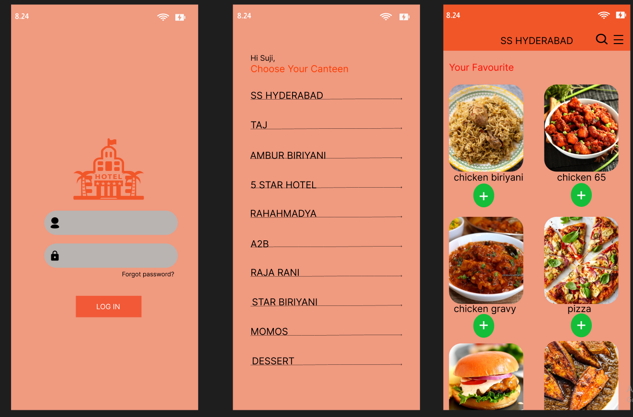

***RESULT:***

***Thus,the* Redesign canteen menu to increase the ease of use and ease of functionality is successfully done.**